Tyndale House Hebrew Unicode Keyboard
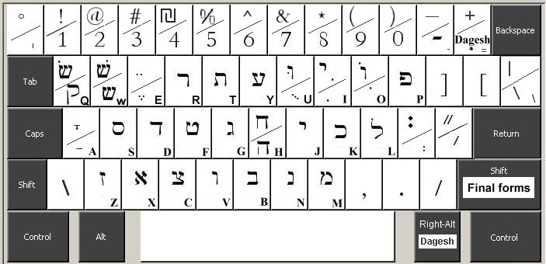
Type dagesh after letter
OR
press Rt-Alt with letter

Shift for final forms
or for long vowels
Caps Lock turns on Masoretic punctuation on the top-row.
Consonants and vowels are in sound-alike and look-alike positions.
Note that aleph = x ; ayin = y ; yod = j ; het = H ; and tet = f.
Shift is used for final forms and for pointed sin/shin (Q & W).
Short vowels are in lower case and long vowels in upper case.
Vowels are typed like they are pronounced - after the consonants.
Sheva = ";" and dagesh = "=", and automatically adjust for different letters.
Right-Alt (or Control+ left-Alt) adds sheva to vowels, and adds dagesh to other letters.
Masoretic punctuation is on the top row with Caps Lock. Add shift for symbols above letters.
Mac keyboard is identical, but use Option for Right-Alt and Option for Shift with Caps Lock.

Tyndale House Greek Unicode Keyboard
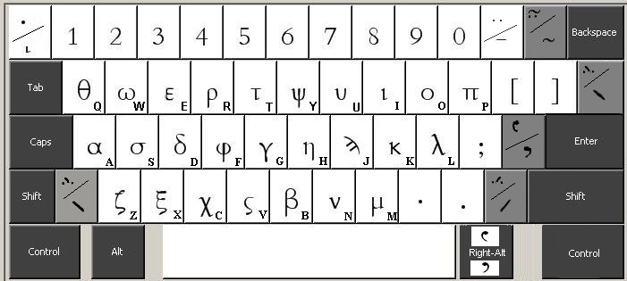
Type Greek accents and breathing before the letter.
Caps Lock turns on Transliteration Type top-row accents after letters.
Shift puts them above letters.
To add breathing, hold Right-Alt (or AltGr) with apostrophe or with accents for combinations.
Add Shift for harsh breathing.
eg Hold Right-Alt then tap “/ ”
The letters are in sound-alike and look-alike positions with upper case on Shift.

Note that theta = q; psi = y ; phi = f ; and final sigma = v.

Type accents with \ / or = before letters.

Breathing is Right-Alt plus ‘ or plus an accent. Add Shift for harsh breathing.
Add iota subscript (on the top-left key) after the letter.
For Transliteration switch on Caps Lock. Add shift for accents above letters in top row.
Mac keyboard is identical, but use Option for Right-Alt and Option for Shift with Caps Lock.
Keyboards © David Instone-Brewer of Tyndale House, Cambridge, 2005
These keyboards are free. If you feel grateful, you may donate $5 or $10 to my favorite Biblical Studies charity, Tyndale House.
Go to www.PayPal.com and donate to PayPal@Tyndale.cam.ac.uk. I programmed them in my spare time, so they are my donation.

